1. Creating and Renaming Files/Directories

Create a directory named test_dir using mkdir.

Inside test_dir, create an empty file called example.txt.

Rename example.txt to renamed_example.txt using mv

Solution :

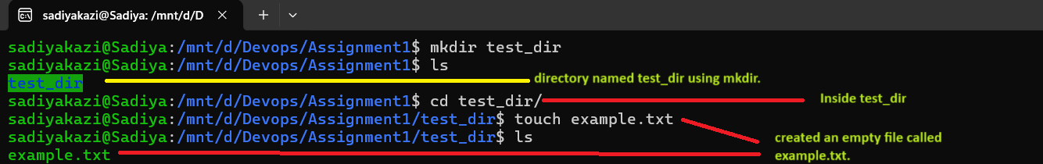



Used  mkdir test_dir to create a directory. Next, navigated inside the directory and used touch example.txt to create an empty file. Lastly, used mv example.txt renamed_example.txt to rename the file. In this manner, the file is created and renamed inside the directory successfully.

2. Viewing File Contents

Use cat to display the contents of /etc/passwd.

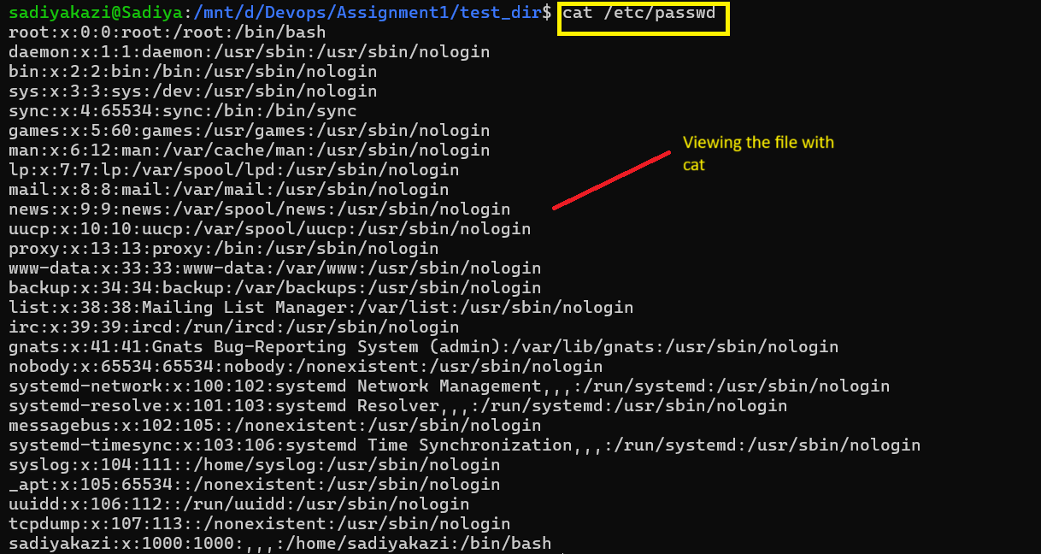

Display only the first 5 lines of /etc/passwd using head.

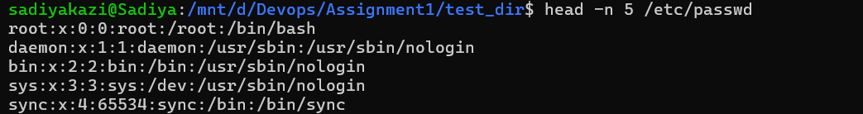

Display only the last 5 lines of /etc/passwd using tail.

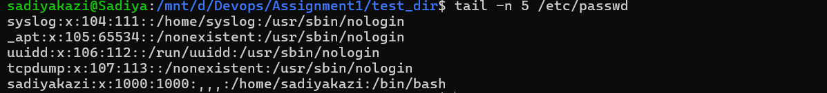

* To view the contents of a file, you can use the cat command. For example, cat /etc/passwd displays the **entire content** of the /etc/passwd file.
* To see the beginning of the file, you can use head -n 5 /etc/passwd, which shows only the **first 5 lines**.
* To view just the end of the file, you can use tail -n 5 /etc/passwd, which displays the **last 5 lines**.

3.Searching for Patterns

Use grep to find all lines containing the word "root" in /etc/passwd.



To find lines containing a specific word in a file, use cat with grep. For example, cat /etc/passwd | grep "root" first uses cat /etc/passwd to display the entire content of the /etc/passwd file and then pipes it (|) to grep "root", which **filters and shows only the lines containing the word "root"**. The output will display details, such as **root:x:0:0:root:/root:/bin/bash**.

4. Zipping and Unzipping

Compress the test_dir directory into a file named test_dir.zip using zip.



Unzip test_dir.zip into a new directory named unzipped_dir.

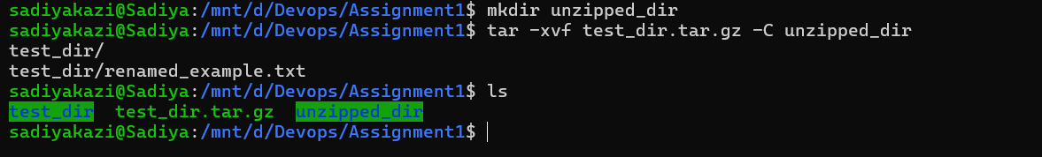

* To compress a directory in Linux, you can use the tar command. For example, tar -cvf test_dir.tar.gz test_dir creates an archive named test_dir.tar.gz containing the test_dir directory and all its contents.
* The -c option creates a new archive, -v shows the files being processed, and -f specifies the archive filename.
* To extract the archive into a new directory, first create the directory with mkdir unzipped_dir, then run tar -xvf test_dir.tar.gz -C unzipped_dir.
* The -x option extracts the files, and -C specifies the target directory

5. Downloading Files

Use wget to download a file from a URL (e.g., <https://example.com/sample.txt>).

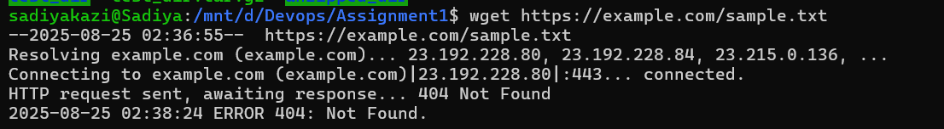

To download files from the internet in Linux, you can use the wget command. For example, running **wget https://example.com/sample.txt** starts downloading the file sample.txt from the given URL to your **current working directory**.

6. Changing Permissions

Create a file named secure.txt and change its permissions to read-only for everyone using chmod.

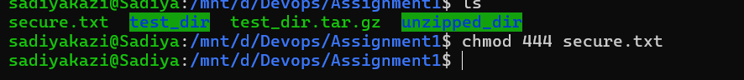

Touch secure.txt to create the file. Then, use chmod 444 secure.txt to make it **read-only for everyone**

7. Working with Environment Variables

Use export to set a new environment variable called MY_VAR with the value "Hello, Linux!".



You can create a new environment variable called MY_VAR and assign it the value **"Hello, Linux!" using the command export MY_VAR="Hello, Linux!".** You can check that the variable is set correctly by running echo $MY_VAR, which will display Hello, Linux!.

**Submission Guidelines -:** Attach Screenshots or command along with explanation and submit in doc(google doc or microsoft doc) format also attach github repo link